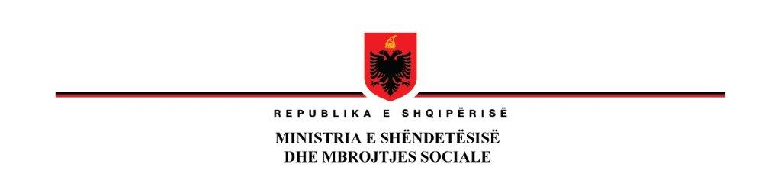

**24th of December 2020**

**NOTIFICATION OF AWARD**

|  |  |
| --- | --- |
| **Country:** | Albania |
| **Project Name:** | HEALTH SYSTEM IMPROVEMENT PROJECT (HSIP) |
| **Loan Number:** | 8466 AL |
| **Number of Lots** | N/A |
| **Contract name:** | ‘Civil Works for Construction of Regional Hospital of Laçi’ HSIP/CW/ICB/01-2020 |
| **Name of the**  **Awarded bidders (winner)** | Consorzio Nazionale Cooperative di producione e Lavoro “Ciro Menotti” Societa Cooperativa per Azioni |
| **Price** | 349,210,674 Albanian Leke Including VAT |

**Bidder who wishes to ascertain the grounds, on which its bid was not selected, should request an explanation from the Project Coordination Unit and Ministry of Health and Social Protection.**

**MINISTËR**

**Ogerta MANASTIRLIU**

**Detailed information on the Bidders who submitted Bids for this tender:**

|  |  |  |  |  |  |  |
| --- | --- | --- | --- | --- | --- | --- |
| **Bidder Identification** | | | **Read-out Bid Price(s)1** | | **Evaluated Price(VAT inclusive)** | **Results of Evaluation** |
| Name | **City/State or Province** | **Country** | **Currency(ies)** | **Amount(s) or %** | *Evaluated price after applicatiosn fo discounts/mathematical errors ect as per the bidding documents* |  |
| JV Green Line Geenral Trading and Contracting CO.W.LL& CO 1 Rroku Construction Tirana sh.p.k | Kuwait/Tirana | Kuwait/Albania | Albanian Leke (ALL) | 367,440,685 ALL  2,999,516 Euro  and **7 % discount** | **341,844,418 ALL** | **Rejected as not responsive (post) qualification criteria not fulfilled)** |
| Consorzio Nazionale Cooperative di producione e Lavoro “Ciro Menotti” Societa Cooperativa per Azioni | Ravena | Italy | Albanian Leke (ALL) | 348,721,155 ALL | **349,210,674 ALL** | **Awarded Bidder** |
| 4 A-M sh.p.k | Tirana | Albania | Albanian Leke (ALL) | 381,117,555 VAT excluded  3,111,164 Euro VAT Excluded | **381,490,515 ALL** | **Evaluated** |
| CURRI sh.p.k | Tirana | Albania | Albanian Leke (ALL) | 381,761,523 ALL | **381,885,787 ALL** | **Evaluated** |
| JV Alba Konstruksion &ACG ADA Consulting group | Tirana /Tirana | Albania | Albanian Leke (ALL) | 410,605,589 ALL VAT included  355,116,306.2 VAT Excluded | 412,145,185 ALL | **Evaluated** |